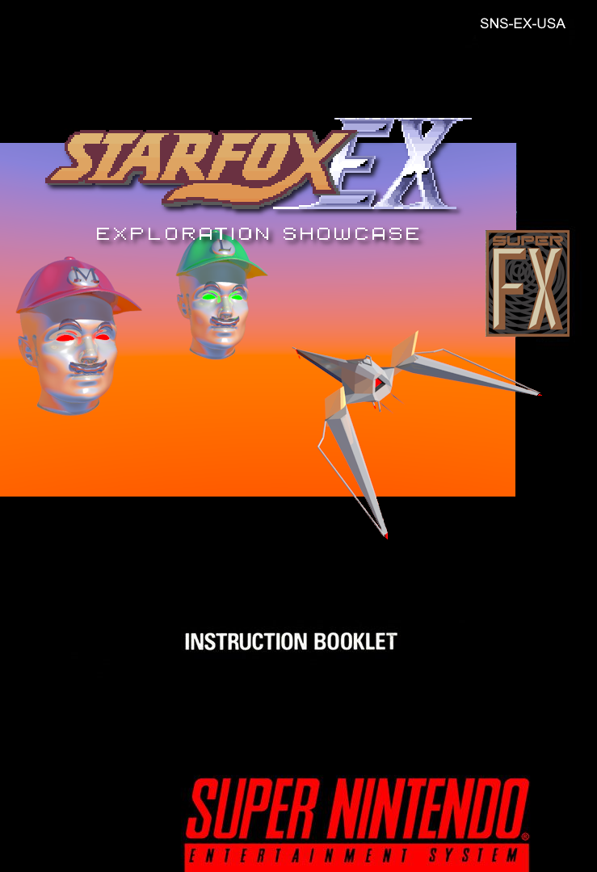
WARNING: PLEASE CAREFULLY READ THE LEGAL DISCLAIMER BELOW BEFORE PLAYING.


This game is neither licensed by, authorized, nor endorsed by Nintendo Co., Ltd.
Star Fox is ©1993 Nintendo Co., Ltd.
This game is non-commercial.
This game has been and will always be free.
If you paid for this game, you were scammed.

Thank you for selecting this Super Kandowontu Entertainment System STAR FOX EX game pak.

Please read this instruction booklet thoroughly to ensure proper handling of your new games. Then save this booklet for future reference.

TABLE OF CONTENTS
Welcome to Star Fox EX! ··············································2
Installation and Getting Started ·····································3
The Pre-Game Menu ·················································· 5
In-Game Commands ··················································· 12
The Pause Menu ························································ 14
Other Details ······························································17
Miscellaneous Notes ··················································· 21
Credits ···································································· 24

Star Fox EX Manual v2.0 - Updated as of game version 1.11.02

Welcome to Star Fox EX!
The Star Fox Team is back! But this time, their mission is to fight for their very existence!

The Mario Bros. have decided that the Star Fox franchise no longer has a place within the grand Nintendo universe, and has set out to destroy the Lylat System forever, with the help of characters from more successful Nintendo IPs! They have also posed as Andross in order to hire the infamous Star Wolf team, a rival band of mercenaries led by Wolf O’Donnell, to distract Star Fox while they pull off their plans! Can Fox and his team put aside their former friendship with the Nintendo All-Stars to save both the Lylat System and everything associated with their franchise?

Star Fox EX began as a simple set of mods for the game meant to demonstrate what was possible with the full source code and some clever coding.
It has evolved from a personal project to a complete DLC/Addon for the original Star Fox game, including new courses, backgrounds, music, models, modes, and secrets.
Experience the amazing power of the Super NES and the Super FX chip and take full control of Star Fox!

We hope you enjoy Star Fox EX!
- Team SFEX

Installation and Getting Started
- Download the archive containing the game patches from the official Romhack Plaza Page. (If you're reading this, you've already done that!)

- Extract the archive. Within will be folders named "SFEX [version number] [region] Patches". Choose the folder that matches the region of your Star Fox/Starwing ROM. (Note: patches for the German version are also in the PAL patches folder.)

- Using a program such as Floating IPS or a web patcher such as the one hosted at Romhack Plaza, Apply the correct patch for your region and version of Star Fox / Starwing.
e.g. "SFEX (USA) (Rev 1) vX.XX.XX.bps" applies to "Star Fox (USA) (Rev 1).sfc" .

There are also optional add-on patches that can be applied to the Star Fox EX ROM after the initial patching, located in the "Optional Add-on Patches" folder. As of the writing of this manual, the only patch within is to replace the new character dialogue mugshots with the older ones used in 1.11.01 and earlier. Apply this if you wish.

If you are going to be playing on a Super NES emulator, go ahead and open the patched Star Fox EX ROM in your emulator.

If you are using an SD2SNES or FXPak Pro:
- Ensure the power is off on the Super NES Control Deck.
- Remove its SD card and insert it into your computer.
- Copy the Star Fox EX ROM to its SD card and reinsert the SD card into the cartridge.
- Power on your Super NES Control Deck and select the game from the on-screen file browser to start the game.

Installation and Getting Started (Cont'd.)
Tip: To improve game performance, the SD2SNES and FXPak Pro support increasing the speed of the Super FX chip. To do so:
- Press the X button on your Super NES controller while in the SD2SNES/FXPak Pro menu.
- Select "Configuration", then "Chip options".
- Set "SuperFX Speed" to Fast by highlighting the option with the + Control Pad, Pressing A, then up on the + Control Pad and A to switch to Fast mode, then press RESET.
- Wait a moment, then turn the power off then on again on the Super NES Control Deck. You should see the file browser once again.
- Please note that this will take effect on all Super FX software, not just Star Fox EX.

Various Super NES emulators (e.g. Mesen 2, SNES9x) and FPGA-based systems (e.g. MiSTer FPGA) may also support increasing the Super FX and Super NES CPU speed. Consult your emulator or FPGA system's documentation to find out how.

The Pre-Game Menu
After the startup introduction sequence and title screen, you will be greeted by the Pre-Game Menu (pictured). You can use this menu to configure the game to your preference.
Use the + Control Pad, L, R, and START buttons to navigate this menu.
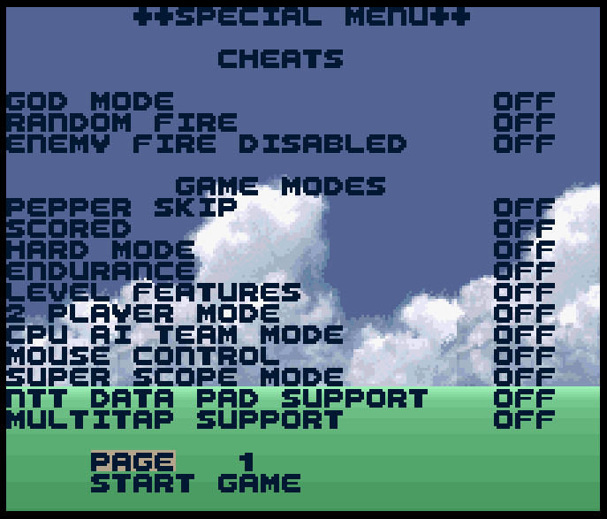

The Pre-Game Menu

The following is an explanation of each option on each page.
The controls described for the features within this menu apply to control type A.

Page 1
Section 1: CHEATS

1) GOD MODE
- Disables collision
- Enables faster boosts with X+B, L+R+X and L+R+X+B
- Enables GOD NUKE. Press R+A to spawn a bomb that kills all objects on screen.
- Lives are removed from the on-screen display
- This is automatically disabled with NEW GAME+, unless...?
2) RANDOM FIRE
- You fire a random weapon for each shot
3) ENEMY FIRE DISABLED
- Enemies do not fire at the player (for the most part)

The Pre-Game Menu (Cont'd.)
Section 2: GAME MODES

1) PEPPER SKIP
- Skips the planet zoom-in and briefing from Gen. Pepper.
2) SCORED
- Enables the on-screen score counter and applies changes found in "Scored Edition Changes.txt".
3) HARD MODE
- Disables all laser upgrades.
- You start with 2 bombs.
- Laser damage is halved.
- No continues.
- Secret boss at end of courses 1/2/3/4.
4) ENDURANCE
- Works for courses 1 and 4 only.
- Course 1 has the following levels back to back:
- 1-1, 2-1, 3-1, 2-2, 2-3, 3-3, 2-4, 3-5, 1-4, 2-6, 3-7
- Course 4 has all of the bosses back to back.
5) LEVEL FEATURES
- Enables "level features" for Map 1 (original Star Fox levels) only - see Other Details for more information.
6) 2 PLAYER MODE
- Enables 2 player mode - works with scope mode.
- Death/views are handled differently in this mode.
WHEN MULTITAP MODE IS ON, THIS CHANGES TO:
6a) NUMBER OF PLAYERS
- Selects the number of players for multitap mode.
- Set to 1 player to control all 5 from player 1 controller.
7) CPU AI TEAM MODE
- Enables 2 player or 4 player CPU assistants.
- They will play the game with you, hunting down enemies.
8) MOUSE CONTROL
- Enables game control using the Super NES mouse. Connect the Super NES mouse to Controller port 2. See Mouse Controls section in Other Details.

The Pre-Game Menu (Cont'd.)

9) SUPER SCOPE MODE
- Enables Super Scope control (on port 2 only).
- Controls second player in 2 player mode.
- Jumps to calibration screen before starting game.
(NOTE: MOUSE AND SCOPE CANNOT BE USED TOGETHER)
CALIBRATION SCREEN:
  - Press "C" button on scope when centered to calibrate.
  - Press "Fire" to test.
  - There is also a mini-version of Star Fox Paint. Use A and B to change color and L and R to change the brush size.
10) NTT DATA PAD SUPPORT
  - Enables NTT Data Pad controller input.
  - There are special inputs unique to this controller. See NTT Data Pad section in Other Details.
11) MULTITAP SUPPORT*
  - Enables SNES Multitap Support, enabling up to 5 players.
  - Select the amount of players above at (6) after turning this on.
*WARNING: IT IS STRONGLY DISCOURAGED to use multitap mode on a real Super NES, as it may result in damage to your console and its power supply.

The Pre-Game Menu (Cont'd.)
Page 2
Section 1: Mods

1) RAINBOW LASER
- Makes each laser shot a different color.
2) MODEL SIZE
- Sets all model sizes to 1x, 2x, or 4x size.
3) WIREFRAME MODE
- Enables wireframe mode.
- Set to ON+ for mixed polygon/wireframe mode.
4) SCRAMBLE SKIP
- Skips the scramble cutscene in all courses.
5) DARK MODE
- Light sources never hit anything.
6) OBJ PALETTE
- Changes the entire game's 3D object palette to your selection
7) NO BACKGROUNDS
- Completely removes all backgrounds, leaving it black
8) NO DOTS/SNOW/STARS
- Removes ground dots, snow, and stars.
9) DISABLE BGM/SFX
- Disable all music, sound effects, or both.
10) SHOW PLAYER COLBOX
- Adds red boxes showing the player's wing/body collision boxes.
11) -NAN MODE
- Wonderful, mysterious things...
- See section: -NAN MODE in Other Details.
12) BGM SPEED
- Speed up or slow down all of the music tracks greatly.
13) 21.4 MHZ SUPER FX
- Enables the full Super FX chip speed of 21.4 Mhz. (The original Star Fox was released with 10.7 Mhz Super FX chip speed).
14) BOUNCY DEATH MODE
- A fun mode, leading the player to remain in complete control of the arwing after dying, never fully reaching death.
- This is a joke mode, expect the game to break!
15) NO ENGINE SOUNDS
- Turns on or off the ship's constant in-air engine noise.

The Pre-Game Menu (Cont'd.)
16) BACKGROUND
Changes the background for the Pre-Game Menu.
17) FPS MENU
PAL/NTSC Mode
  - Changes the video output standard used by the game.
MAX FPS*
  - Allows you to play the game in 30 or 60 FPS mode.
  - Objects are delayed and spaced out to try to account for this.
  - *DOES NOT WORK ON SUPER NES HARDWARE OR MISTER - ALL EMULATORS NEED CPU OVERCLOCK FOR THIS MODE TO FUNCTION AS INTENDED:
    - SNES9x: MAX CPU OVERCLOCK
    - BSNES: 126% OR GREATER CPU OVERCLOCK
    - MESEN 2/MESEN CE: WAIT 300 SCANLINES BEFORE NMI and MAX CPU OVERCLOCK
FPS COUNTER
  - Enables an on-screen display on the current Frames Per Second
NO OBJECTS
  - Prevents map objects from spawning.
18) CONFIG LOAD/RESET
RESET TO DEFAULTS
  - Allows you to reset the game configuration to defaults.
CLASSIC PRESET
  - A configuration preset for those who prefer vanilla Star Fox game play.

The Pre-Game Menu (Cont'd.)
Page 3

1) SHIP SELECT
- Allows you to to change the player's ship.
- All hitboxes are the same.
- Has a model view option as well.
- Pressing START while the SHIP option is highlighted selects a random ship model.
2) CROSSHAIR MENU
- Allows you to select the NEW, ORIGINAL or NO crosshair for 1st+3rd person.
- Can select a different crosshair for each player in 2/3/4/5 player mode.
- Some crosshairs are animated!
3) MODEL VIEWER
- Full model test/viewer mode. Hold SELECT for instructions.
4) SOUND TEST
- Full Sound and Music test
- Some Sound FX only play with certain tracks loaded (You can load a track, fade out, and then test SFX)
- Pressing L+R enables "CURSED BGM MODE" where you can enjoy creepy cursed versions of every track
- Pressing X+A loads SUB TRACK test (can crash game)
- LEFT/RIGHT on Track Number/Sound FX Number to change
- START to play Track/SFX
5) THANKS
- A simple thank you to people who have supported this project
6) NTT PAD TEST
- A test to make sure all extra NTT Data Pad buttons work
7) MULTITAP TEST
- A screen to test buttons for all controllers for multitap mode
8) RANDOMIZE LEVELS
- Will randomize each level up to the last level in a course from the current map's selection.
9) RANDOMIZE OBJ PALETTE
- Will randomize the color palette for 3D objects every time a level is loaded.
10) RANDOMIZE BG PALETE
- Will randomize the background palette every time a level is loaded.
11) GRID LINES
- Turns the grid dots into grid lines (thanks to Chuckborrisnorris).
12) NO HUD
- Enable or disable the in-game Heads-Up-Display (HUD). (shield, lives, bombs, etc.)

The Pre-Game Menu (Cont'd.)
13) CLASSIC HP/WING DMG
- Enables or disables classic HP/Wing damage
- Classic: HP = 40, Wings have 5 hits each
- New: HP = 100, no wing damage
14) CLASSIC CAMERA
- Switches the camera system back to its behavior in the original Star Fox.
15) RAPID FIRE
- Your ship will continue firing as long as the fire button is held.
16) BOOST/BRAKE METER
- Enable this to enable the boost/brake meter with all its limitations as in the original Star Fox.
17) MORE DOTS/SNOW/STARS
- Takes advantage of the additional MARIO RAM (Super FX work memory) by adding more particles to the play area.
18) HOLD TO BARREL ROLL
- Holding L or R while performing a barrel roll will continue to spin with this option enabled. This will be automatically disabled at certain bosses to prevent unintended game behavior.
PAGE #
- Pressing Left/Right on the + Control Pad while this option is highlighted changes the current Pre-Game Menu page. Pressing L or R at any time in the Pre-Game Menu does the same.
START GAME
- Pressing START while this option is highlighted exits the Pre-Game Menu and enters the Controls screen.

In-Game Commands
During game play, there are button combinations you can press that enable special game features.
1) View Changes
- Holding LEFT, RIGHT or UP and pressing SELECT changes to one of three different angled views.
- Holding DOWN and pressing SELECT switches to a realistic cockpit view where the world rotates around instead of the ship.
- First Person and Third Person are always selectable with SELECT.
2) Super Boost/Hyper Boost/Warp Boost (GOD MODE ONLY)
- Fly even faster by holding X and then holding B!
- Want to go to ludicrous speeds?
  - HOLD L+R and then hold X to fly at a HYPER rate!
  - HOLD L+R+X and B to fly at WARP SPEEDS!!
3) God Nuke (GOD MODE ONLY)
- Hold R and fire a bomb. It will destroy all enemies on-screen.
4) TESTING COMMANDS
- Hold L+R and press SELECT to complete the level instantly.
- Hold L+A and press START to kill the player instantly.
  - This also works with player 2.
- Activate GOD+ mode: ???
- Activate GOD+ mode in-game: ???
- HOLD L or R while starting TRAINING to start 1 of 2 message tests.

The Pause Menu
Pausing the game with the START button reveals lots of options and game status information.
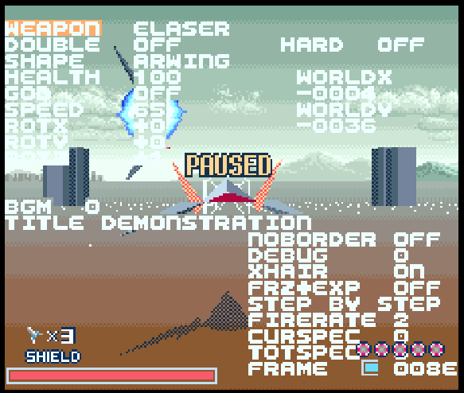

The Pause Menu
The pause menu options are as follows:
1) WEAPON
- Pressing left/right changes your current weapon.
- God gun 99 removes all objects it encounters.
- Weapons can be overpowered, so use with levity in mind.
2) DOUBLE
- Enables/Disables dual shots for some of the custom weapons.
3) SHAPE
- Changes your current ship model.
4) BGM
- Highlighting this and selecting a track and then unpausing will change the current level track.
5) NOBORDER
- Removes all borders and movement limitations.

The Pause Menu (Cont'd.)
6) DEBUG
- Set to 1 to have the top half of pause menu always display.
- Set to 2 to have entire pause menu always display.
7) XHAIR
- Turns crosshair on and off.
8) FRZ+EXP
- Freeze and Explore Mode
  - Once turned on, Press the BRAKE button to stop the ship in its tracks.
  - Move forward and backwards with X and B.
  - Completely removes the rails, allowing you to move at your own pace.
9) STEP BY STEP
- While highlighted, you can press left/right to advance by single/multiple frames, to move the game in a step by step fashion.
- While holding left and right, up, down and fire will work.
10) FIRERATE
- How long of a delay each laser shot has before the next shot.
- Default is 2. 1 can cause the game to hardlock in rare situations.

The Pause Menu (Cont'd.)
GAME STATUS INFORMATION
HEALTH
- The player's shield energy level.
GOD
- Indicates if god mode is on or off.
SPEED
- Reports the current ship speed.
ROTX/Y/Z
- Reports the current ship rotation.
WORLDX/Y
- Your ship's position in the world.
HARD
- Indicates if Hard mode is on or off.
CURSPEC/TOTSPEC
- Indicates the total "special" enemies spawned and total "special" enemies killed. These are the enemies programmed to affect the score percentage at the end of the stage.
FRAME
- Current game frame in the level (resets every level).

Other Details
-NAN MODE
  - 1: Sets all polys to use the white -NAN texture.
  - 2: Sets all polys to use the animated lava texture.
  - 3: Sets all polys to use the animated blue lava texture.
  - 4: Sets all polys to use the electric animated texture.
  - 5: Sets all polys to use the Trevor the Cat texture.
  - 6: Enables "Wobble mode 1".
  - 7: Enables "Wobble mode 2".
  - 8: Enables "Wavy Mode".
  - 9: Enables "Cel Shading" mode.

Other Details (Cont'd.)
NTT DATA PAD CONTROLS
  - 0 - Fire Missile
  - Hang up - Destroy your ship
  - * - Kill all enemies
  - .- Super Homing Laser
  - #- God Gun
  - C- Orb Shot
  - 1/3 - All-range turning
  - 5 - Center camera
  - 4/6 - Rotate camera left/right
  - 2/8 - Rotate camera up/down
  - 7/9 - Zoom in/out
MOUSE CONTROLS
  - Left click fires your laser.
  - Right click fires a bomb.
  - Both buttons either boost or brake. Double clicking both buttons within 9 frames will swap the mode between boost and brake.
  - Move mouse/use + Control Pad on Controller 1 to aim.
  - The Controller in port 1 can also be used alongside the mouse as a sort of keyboard.
  - If you're playing on a PC-based Super NES emulator with a controller, you can map mouse input to the analog stick with a program such as Joy2Key to play the game with analog flight controls.

Other Details (Cont'd.)
LEVEL FEATURES
NOTE: Only works on Map 1 (Original Star Fox Levels)
- 1-1 - Play the level completely with Andross's boss fight background
- 2-1 - New palette for Corneria
- 3-1 - Another new palette for Corneria
- 1-2 - Spawns a group of smiling asteroids that leave black hole warps
- 2-2 - Displays a very short *special* credits before continuing the level
- 3-2 - Spawns a group of asteroids that all spawn the Out of this Dimension warp bird when destroyed
- 1-3 - Short additional fight with a mix of ships and a new background at the start of the level.
- 2-3 - Fight dodora bird at start of level, new background after weather change, extra fun enemies added
- 3-3 - Fight a funny Macbeth/Andross boss, new background swap for water section
- 1-4 - Walkers. Lots of them. Who doesn't like walkers?
- 2-4 - Enjoy another level using the final boss fight's background!
- 3-4 - Play inside the nucleus for the whole level. And then enter a nucleus within a nucleus.
- 1-5 - Is it the black hole? Nope, just 1-5.
- 2-5 - There is a temporal distortion messing with the background!
- 3-5 - Play Macbeth with a flowing watery type background.
- 1-6 - Complete the "THE END" puzzle to continue.
- 2-6 - Nothing
- 3-6 - It's like that scene from Out of this Dimension but without the slot machine.
- 3-7 - Replay the training level on Venom.

Other Details (Cont'd.)
TITLE SCREEN KEY COMBINATIONS
- HOLD L, PRESS SELECT - Start game in model test mode.
- SUPER HIGH POLY MODE: ???
- HOLD Y, PRESS A, B or X - Change title screen models.
- HOLD R, PRESS SELECT - Cycle through mosaic mode options (tile size, layer).
- HOLD L+R+DOWN+B during the introduction sequence to quickly reset the Save Memory. You will hear a sound letting you know Save Memory has been reset.

Miscellaneous Notes
- The original levels are ~95% faithful to the original. Some enemies may have had to be removed to prevent crashes.
- On MAP 1, Course 4 is a BOSS RUSH course.
- Shield energy has been increased to 100 with no wing destruction (can be turned off)
- In 1 player mode, player 2's controller controls the camera.
  - P2 L+R+RIGHT resets the view.
  - P2 UP/DOWN adjusts X position of camera
  - P2 RIGHT/LEFT adjusts Y position of camera
  - P2 A/B rotates the caemera on the Z plane
  - P2 X/Y zooms in and out
  - P2 L/R turns the player ship in any direction for all range mode
- Great Commander I's 6 panels have increased in size.
- Professor Hanger's HP has been adjusted to accomodate rapid fire.
- Out of this Dimension now leads to The Awesome Black Hole after completion.
- Game can be restarted after credits by pressing START at the "THE END" Screen.
- Australia never ends, just like real life
- Teammates have their own colors, and also actually help the player.
To access the secret menu:
  - During the intro, press X+A (you'll hear a jingle). Then go to page 3 of the Pre-Game Menu, highlight THANKS and press Y+A.
  - (Most things here are best used with god mode)

Miscellaneous Notes (Cont'd.)
To access the secret level:
  - On level 6-3, destroy 7 green asteroids throughout the level.
  - This will spawn a yellow asteroid. Destroy this and fly into the fire.
On MAP 1 (Original Star Fox Levels):
  - Hold R and press X for an ending sequence test (space part)
  - Hold R and press Y for boss bgm test (ancient test I made)
  - Planet Cheat: Hidden courses go directly to Black Hole, OOTD, or a BOSS ROLL test for Map 1.
On MAP 2 (Star Fox EX Campaign):
  - Planet Cheat: Hidden courses go directly to Comet or a BOSS ROLL test for Map 2.
  - To activate god mode+: ???
Kando Mode controls:
  - Flip screen Upside Down: ???
  - Flip screen Left: ???
  - Flip screen Right: ???
  - Duplicate player: ???
  - Duplicate all enemies: ???

Miscellaneous Notes (Cont'd.)
- Cray mode: 1: ???
- 2: ???
- 3: ???
- 4: ???
- 5: ???
- 6: ???
- Other undocumented features and secrets exist!

Credits


Presented by
Team SFEX
Lead Programmers
Kandowontu and Sunlit
Code Contributors
Starxxon
Hayao Yokogawa
CoolK
Phonymike
MrL314
Raphnet Labs
Chuckborisnorris
Catador
Super FX Programmers
Chuckborisnorris
MrL314
Graphics
SegaRetro92
Hayao Yokogawa
Sunlit
Fenix
Random Stuff
Morshu
Onaji
Models
Euclidium
Random Stuff
CoolK
SegaRetro92
Ben Hickling
Mighty Andross 64
Sunlit and Monika
Music
Random Stuff
Livvy94
Phonymike
Plasmariel
eg_9371
StudsX
Shub
Testing
Sunlit
Chromius
Random Stuff
CoolK
Chris Highwind
SolGnar
Joshua Schaeferhund
Ideas
Sunlit
CoolK
Random Stuff
Joshua Schaeferhund
Phonymike
DoctorWhosThat
Thanks
Original Star Fox Development Team
Argonaut Software Ltd.
Dylan Cuthbert
Giles Goddard
Nintendo Co., Ltd.
Kando and Team SFEX Thank you for playing.
Be happy and prosperous!
This game is not for profit.
This game has been and always will be free.
Please support:
Q-Games
Chuhai Labs
Nintendo

Specific Credits (Names in Alphabetical Order)
Ben Hickling - Ex-Zodiac models used in this game
Catador - General ASM help, NTT Data Pad/Mouse/Super Scope programming help
Chromius - ROB-FX character mugshot graphics, Benchmarking, Ideas
Chris Highwind - Story writer, Ideas, Testing
Chuckborisnorris - Super FX programming (Background effects, Wireframe/Wobble modes, Grid lines)
CoolK - Script/Credits editing, General gruntwork/documentation, ASM modifications, Testing
DoctorWhosThat - Ideas, Testing
EarthBound Music Editor Developers - Creating/developing EBMusEd (N-SPC music editor/tracker)
eg_9371 - Route 7 final boss music
Euclidium - Modeling, Model conversion tools, Model conversions, Box/Cover artwork
Fenix - Metroid Sprites
Hayao Yokogawa - Title screen logo, Map 2 background
Joshua Schaeferhund - Ideas, Scored Mode testing, General testing
Kandowontu - Lead developer, 65816 ASM programming
Kert Gartner - Trailer video
KungFuFurby - N-SPC/SPC700 technical
Livvy94 - Music Contributions, Music Transcriptions, Music technical, Script writing
Monika - Monikruiser ship model
Morshu - Custom crosshairs
Mighty Andross 64 - Y-Fighter ship model
MrL314 - Super FX programming (Texture limit expansion), Music BIN unpacker tool
Onaji - New Character Mugshots
Phonymike - Music/sound disassembly, SPC700 ASM, Tool maker, General lifesaver, NTT Data Pad/Mouse/Super Scope programming help
Plasmariel - Music Contributions
Random Stuff - Music, Models, Levels, Map 2 background
Raphnet Labs - NTT Data Pad programming help
SegaRetro92 - Graphics, Palettes, Level backgrounds, Map 2 background
Shub - Music Contributions
Starxxon - Luigi head model, Original Camera Controls/Iso Views, PAL Test
StudsX - Music Contribution
Sunlit - Current lead programmer, Classic character mugshots, Misc. Graphics, Bugfixes, Toolchain engineering, Graphics/Modeling tools, Testing, Ideas, Instruction manual authoring, Quadwing ship model

Tester Credits
Many, many testers, including, but not limited to:
BlazingRaven495
Brozilla
Chris Highwind
Chromius
CoolK
Darkhorse
djedditt
DoctorWhosThat
Joshua Schaeferhund
kaine23
Kert Gartner
Mike Bachmann
Phonymike
Random Stuff
Sfan
Solgnar
Sunlit
